

FACULTY OF ENGINEERING AND TECHNOLOGY

A REPORT ON THE APPLICATION OF NUMERICAL APPROXIMATION METHODS AND DIFFERENTIAL EQUATIONS USING MATLAB BASED ON RECURSIVE PROGRAMMING AND COMPARATIVE ANALYSIS OF RECURSIVE AND DYNAMIC PROGRAMMING APPROACHES FOR THE KNAPSACK AND FIBONACCI PROBLEMS

COURSE UNIT: COMPUTER PROGRAMMING
LECTURER: MR. MASERUKA BENEDICTO
GROUP 13
SUBMITTED BY
NAME | COURSE | REG. NO.
NASASIRA AUSTINE | WAR | BU/UP/2024/1048
NYEMERE ANNA GRACE | AMI | BU/UP/2024/0838
BARASA ELVIS | AMI | BU/UP/2024/3817
BRAVO GIFT | PTI | BU/UG/2024/5059
NAMUWAWU PATRICIA | APE | BU/UG/2024/2670
AINAMATSIKO JEREMIAH | WAR | BU/UP/2024/3826
ACHAM LOYCE | AMI | BU/UP/2024/0821
MUGUME MATHIAS | MEB | BU/UP/2024/0983
ABUROT MARTHA | WAR | BU/UP/2024/3823
KINTU GADAFFI | AMI | BU/UP/2024/3734

DATE OF SUBMISSION: ………………………………

DECLARATION
We hereby certify and confirm that the information in this report is out of our own efforts, research and it has never been submitted in any institution for any academic award
NAME SIGNATURE
- NASASIRA AUSTINE …………………………
- KINTU GADAFI ………………………..
- ABUROT MARTHA …………………………
4. MUGUME MATHIAS ………………………….
5. ACHAM LOYCE ………………………….
- AINAMATSIKO JEREMIAH ………………………….
- NAMUWAWU PATRICIA …………………………..
- BRAVO GIFT …………………………..
9. NYEMERA ANNA GRACE …………………………..
10. BARASA ELVIS …………………………..

APPROVAL
We are presenting this report which has been written and produced under our efforts. We carried out research on different numerical methods and developed algorithms to solve the data.

ACKNOWLEDGEMENT
First and foremost, we would like to thank the Almighty God for giving us the strength to carry on with our research as Group 13. We would love to extend our gratitude to all the persons with whose help we managed to make it this far
The willingness of each one of us to invest time and provide constructive feedback has been immensely valuable in this assignment.
Finally, we would like to express our gratitude to all the sources and references that have been cited in this report

DEDICATION.
We dedicate this report to all the individuals especially Group 13 members, who have been there for us in the process of formulating and producing this report.
To our lecturer Mr. Maseruka Benedicto whose guidance and expertise have been invaluable, your mentorship and insightful feedback have shaped our understanding.

ABSTRACT
We started our research from 17th October, 2025 in the university library with division of work for intense research in the different sections, where were obtained the best ways of how to do the assignment and that are used in the engineering field to solve problems.
Information we used was mainly obtained from YouTube tutorials. We carried out research on Newton’s Raphson method solutions using recursive method, The knapsack problem and Fibonacci problem using both recursive and Dynamic programming. The division of work, eased the work and saved time.

Table of Contents
CHAPTER TWO: QUESTION ONE 13
2.1 introduction 13
SECTION 1: NEWTON RAPHSON AND SECANT 13
2.1.1 steps 13
QUESTION TWO 17
Introduction 17
Steps taken 17
Knapsack problem 17
Fibonacci problem 18
CONCLUSION AND RECOMMENDATION 20

CHAPTER ONE: INTRODUCTION
1.1 Background.
MATLAB, which stands for matrix laboratory, is a high-performance programming language and environment designed primarily for technical computing. Its origins trace back to the late 1970s when Cleve Moler, a professor of computer science, developed it to provide his students with easy access to mathematical software libraries without requiring them to learn Fortran.
1.2 Historical Development
Early Development (1970s)
- Origins in Matrix Algebra: MATLAB's foundation was built on research papers by J. H. Wilkinson and others, focusing on algorithms for solving matrix linear equation and eigenvalue problems.
- Academic Tool: Cleve Moler, a mathematics professor, developed the initial Fortran-based version in the 1970s as a free, interactive tool for his students, called the "Matrix Laboratory".
- Basis in LINPACK and EISPACK: This early version used subroutines from the LINPACK and EISPACK matrix software libraries for solving linear equations and eigenvalue problems.
Commercialization and Expansion (1980s)
- Commercial Launch: In 1984, Cleve Moler and John N. Little commercialized the software, founding MathWorks to market it to engineers and scientists.
- Rewritten in C: The commercial version was a significant rewrite of the original Fortran code, incorporating a proper programming language, user functions, and graphics capabilities.
- Toolboxes: Early toolboxes were introduced, including the Control System Toolbox (1985) and the Signal Processing Toolbox (1987), significantly expanding MATLAB's capabilities.
Continued Evolution (1990s to Present)
- Advanced Data Structures: The introduction of sparse matrices in 1992 and toolboxes like Image Processing and Symbolic Math in 1993 marked further advancements.
- Broadened Scope: While initially focused on numerical linear algebra, MATLAB evolved into a comprehensive technical computing environment for a wide range of applications.
- Modern Capabilities: Today, MATLAB supports advanced features such as parallel computing, object-oriented programming, and extensive integration with other languages and platform. It has also introduced features like the Live Editor, which allows users to create interactive documents that combine code, output, and formatted text. This evolution reflects MATLAB's ongoing adaptation to meet the needs of its diverse user base across academia and industry.

CHAPTER TWO: QUESTION ONE

2.1 introduction
Question one required us to do numerical approximation for finding the solutions to functions by newtons Raphson ad secant methods based on recursive programming

SECTION 1: NEWTON RAPHSON AND SECANT

2.1.1 steps
Step 1: drawing flow charts
READ: i, x₀, X₁
STOP
START
i = 0
Numerical method formular i.e.
Secant or newton Raphson
Is |Xi+1 -Xi| < error?
PRINT: X_{i+1}
i = i +1
Xi = X_{i+1}
Actual writing of codes
function root = newton_recursive(f, df, x, tol, maxiter)
if maxiter == 0 || abs(f(x)/df(x)) < tol
root = x;
else x_new = x - f(x)/df(x);
root = newton_recursive(f, df, x_new, tol, maxiter - 1);
end
end
%% secant recursive method
function root = secant_recursive(f, x0, x1, tol, maxiter)
if maxiter == 0 || abs(x1 - x0) < tol
root = x1;
else x2 = x1 - f(x1)*(x1 - x0)/(f(x1) - f(x0));
root = secant_recursive(f, x1, x2, tol, maxiter - 1);
end
end
function [x, y] = euler_recursive(f, x, y, h, steps)
if steps == 0
return;
else y_new = y + h * f(x, y);
x_new = x + h;
[x, y] = euler_recursive(f, x_new, y_new, h, steps - 1);
end
end

% Newton-Raphson
f = @(x) x^3 - x - 2;
df = @(x) 3*x^2 - 1;
root_nr = newton_recursive(f, df, 1, 1e-6, 100);

% Secant
root_sec = secant_recursive(f, 1, 2, 1e-6, 100);

% Euler Method for dy/dx = x + y
f_euler = @(x, y) x + y;
[x_final, y_final] = euler_recursive(f_euler, 0, 1, 0.1, 10);

QUESTION TWO

Introduction
Question two required us to use the concept of recursive and dynamic programming to solve Knapsack and Fibonacci problems, making graphs to compare their computational times

Steps taken

Knapsack problem
Step 1; analysing the problem to be worked on
The codes were to compute the maximum value with capacity W, item weights wt, item values v, considering first n terms using both dynamic and recursive programming techniques
Step 2: writing functions for Knapsack in both recursive and dynamic programming
(i). Recursive programming
We wrote codes basing on the above parameters compute the maximum value with capacity W, item weights wt, item values v, considering first n terms as follows
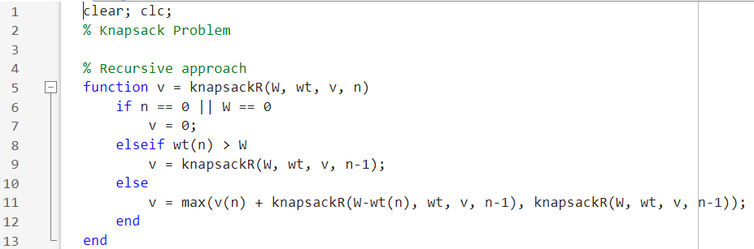
(ii). Dynamic programming
For the above problem in dynamic programming, we wrote the code below to compute the maximum value for capacity. We used loops, if condition and return function to simulate the code as below
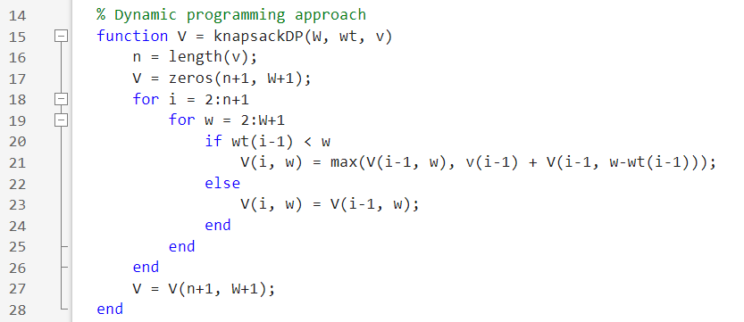

Fibonacci problem
Step 3: writing functions for Fibonacci in both recursive and dynamic programming
(i). Recursive programming
We wrote the Fibonacci function in recursive programming as follows with base cases as n=0 or n=1
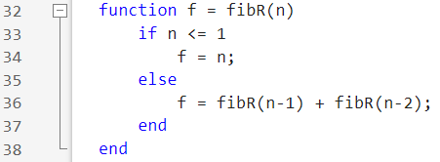
(ii). Dynamic programming
we wrote a function that builds a Fibonacci sequence in an array and returns F(n), runs in linear time 0(n) and uses 0(n) memory.
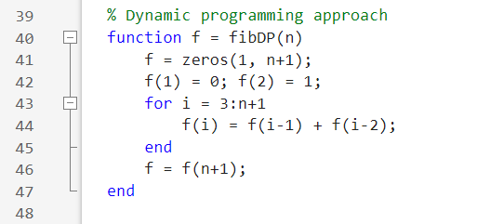
Step 4: testing and timing setup
We allocated n values from 10-30, pre allocated arrays to store execution times for each method problem.
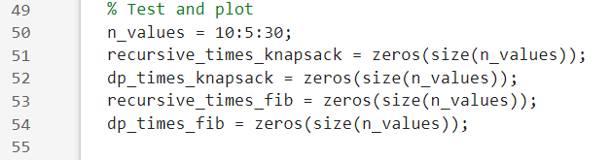
Step 5: loops that run test and records times
For each n,
W set to n*10, wt and v fixed small item sets and also stored the elapsed times for both functions.
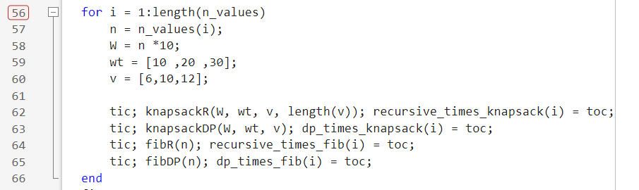
Step 6: plotting both Knapsack and Fibonacci results
We wrote plotting codes for both functions as follows;
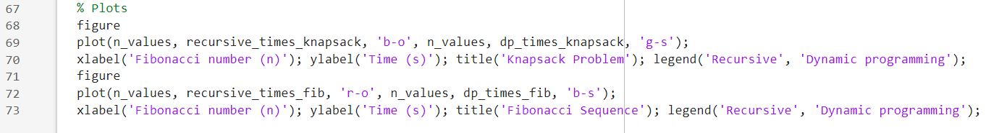
3.3 running the code.
Running the produced the following results
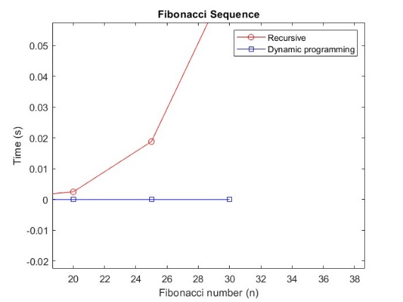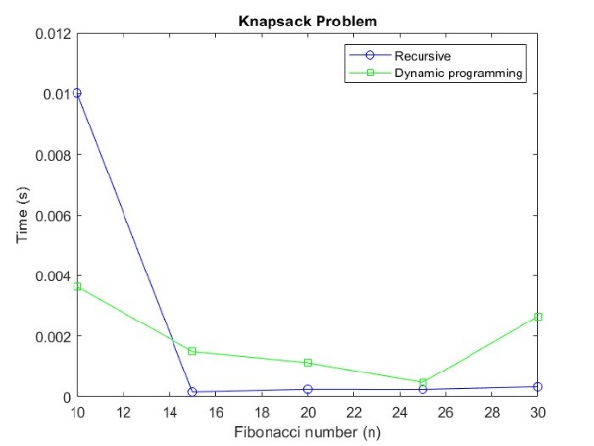

CONCLUSION AND RECOMMENDATION
Conclusions
Dynamic programming (DP) is far superior to naive recursion for problems with overlapping subproblems, like Fibonacci and Knapsack. Graphs show DP's time grows slowly, while naive recursion becomes too slow for larger inputs. The trade-off of using extra memory for massive speed gains is justified
Recomendations
- Use DP over recursion for problems with overlapping subproblems.
- Apply memorization to recursive functions as a simple performance fix.
- Explore other DP problems like Longest Common Subsequence or Coin Change.
- Compare top-down and bottom-up DP methods in future work.

